D.I.R.T by numbers
Directed improvement and reflection time
When students write extended pieces of work it can be easy to write lengthy comments on WWW and EBI. This can result in hours spent on marking a class set of essays. Two simple strategies to reduce marking by a number of hours.
- Produce a feedback sheet. You can then highlight WWW – no need to write it.

- For EBI you notice similar areas that need to be improved on. Instead of writing the same thing again and again just simply use a number. When the students get their work back the codes are displayed. They can then write down what their action for improvement is and then they are given time to reflect and improve.

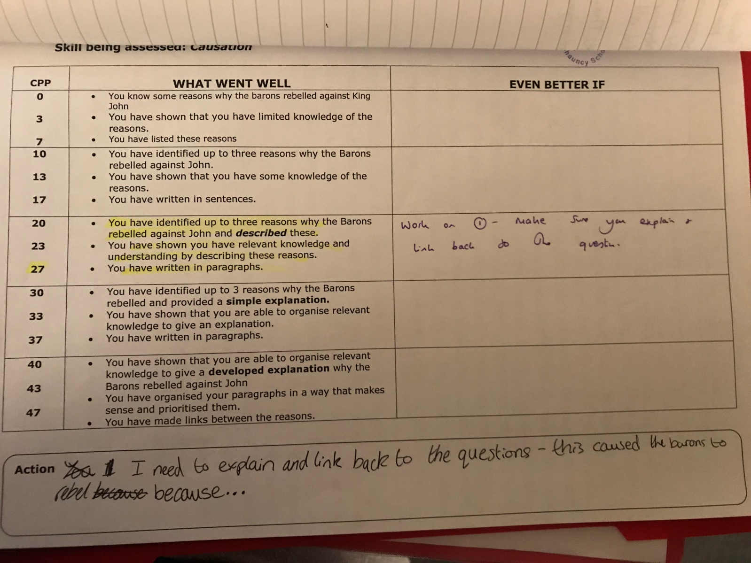
Students write down what they need to do to improve
EBI – number given – in this case a specific point made – however this is not needed
WWW points highlighted

Students then have an opportunity to work on this action in green pen.

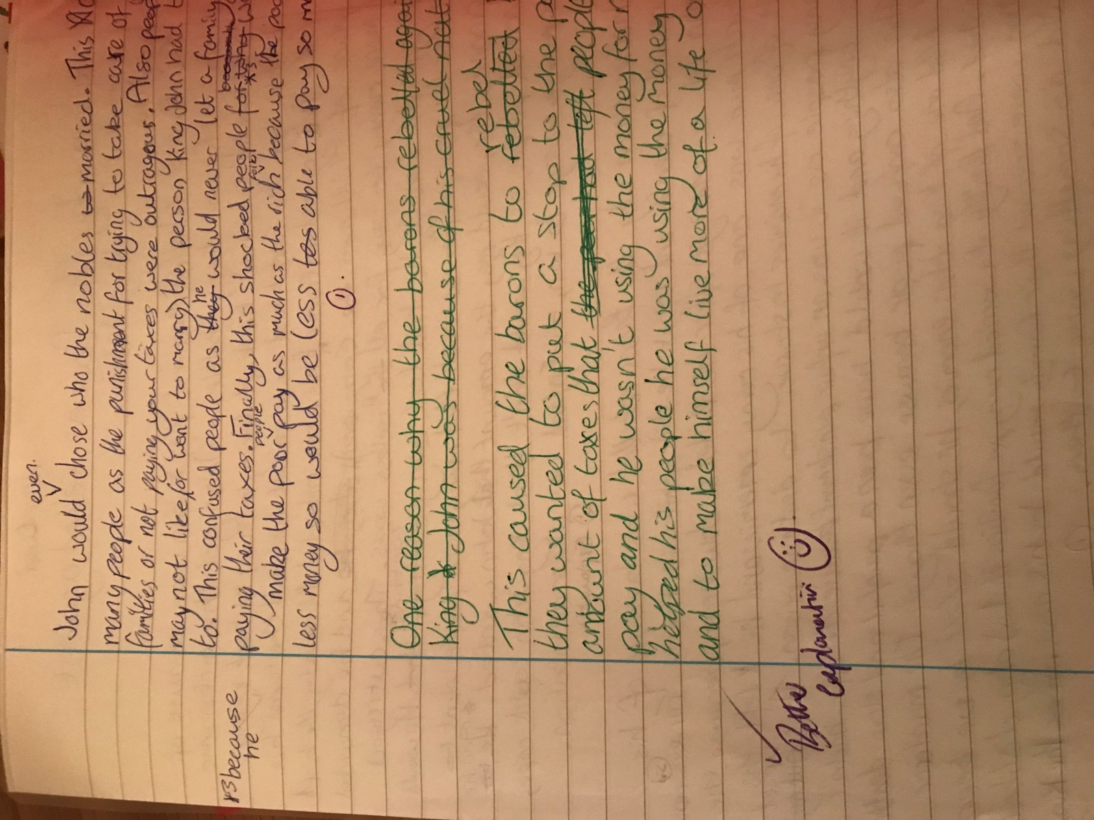
Improvements made by students
Use of the number to pinpoint a specific area for action
Simple checking by teacher

Pros:
Reduces marking time – before it would take around 2 hours to mark a set of 32 assessments. With this method around 45 minutes.
Things to consider:
Pre-prepare feedback sheets
You could have a standard list of codes use in the front of an exercise book to make marking even easier.

